National Junior College
2012 SH2 H1 Prelim
Answer Scheme
Pure Mathematics [35m]

1i | 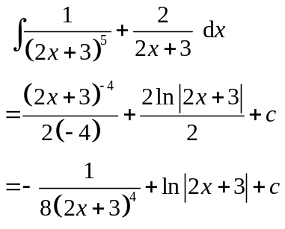
1ii | 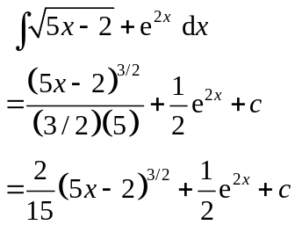
1iii | Using GC, 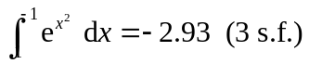
2i | 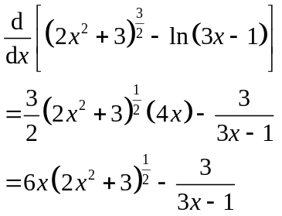
2ii | 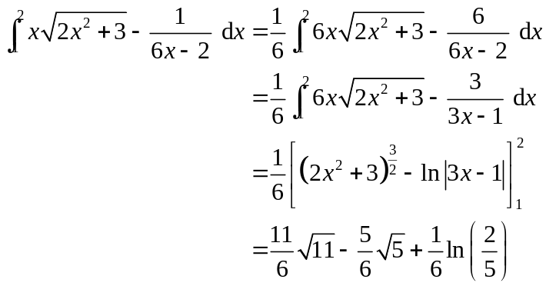  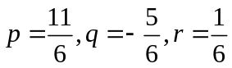

3i | 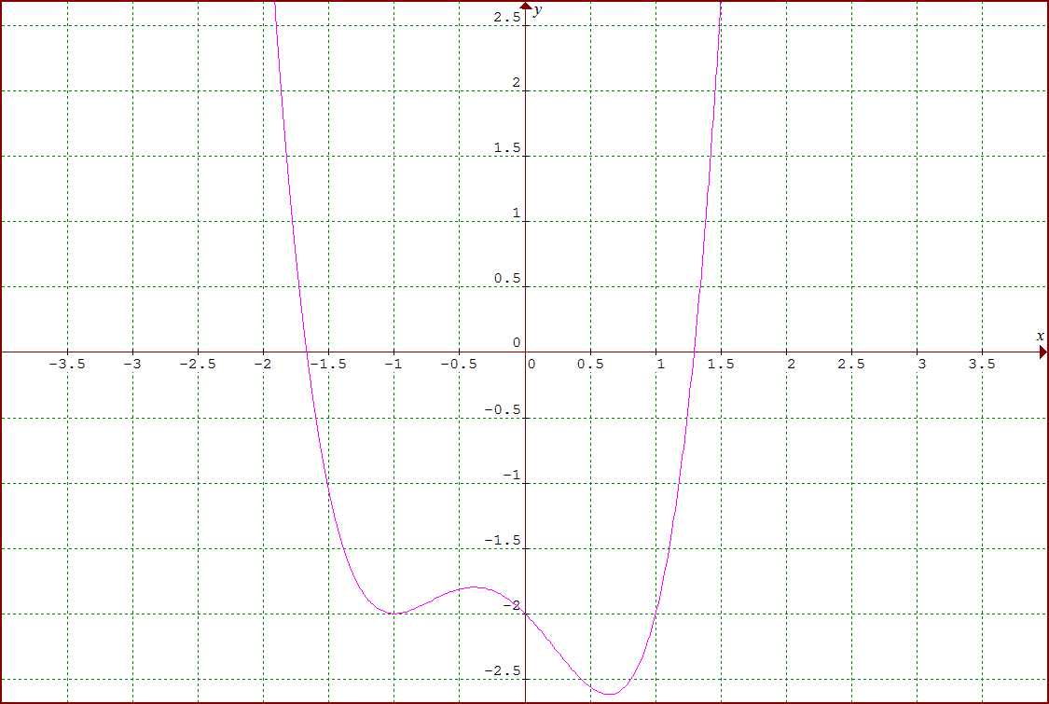  Axial intercepts: (-1.67,0), (1.29,0), (0, -2)  Stationary points: (-1, -2), (-0.390, -1.80), (0.640, -2.62)
3ii | 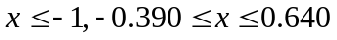
3iii | 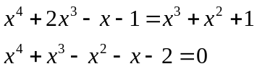
3iv | 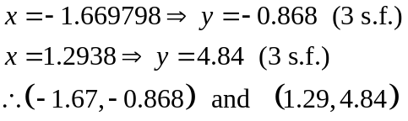

4i | 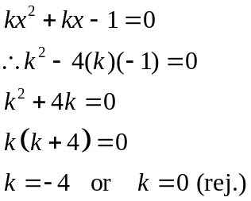  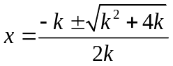  For 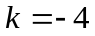,  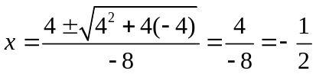
4ii | 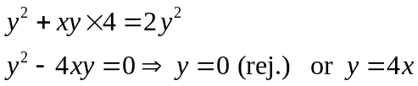  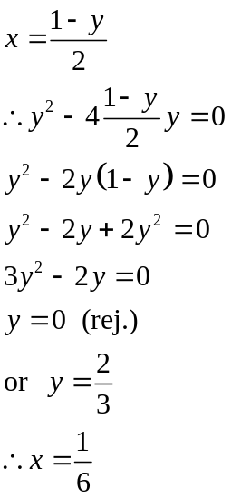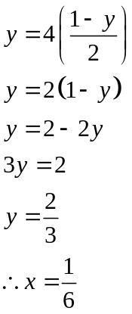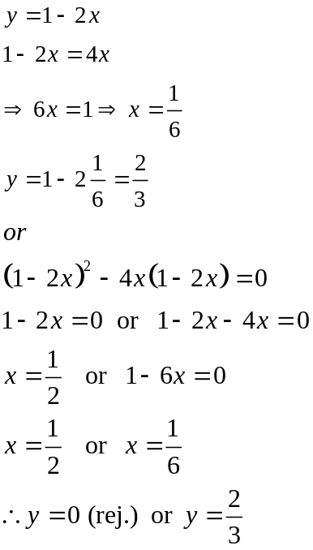

5ai | 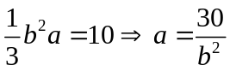
5aii | 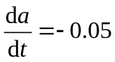 , 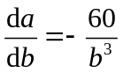  When 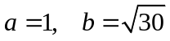  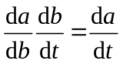 so 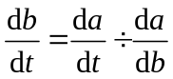  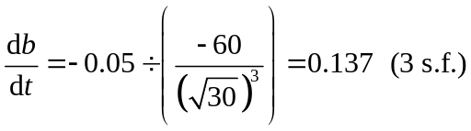
5b | 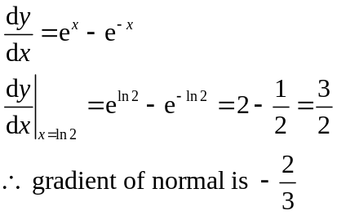  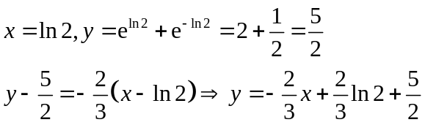  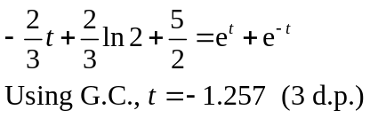

Statistics [60m]
6i | 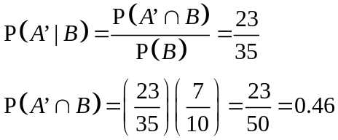
6ii | 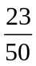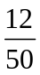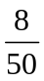  A  B  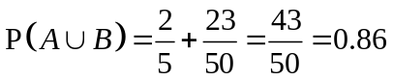
6iii | Since B and C are independent,  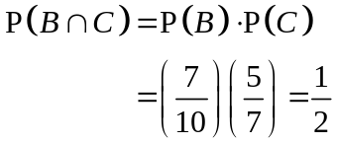
6iv | We note that 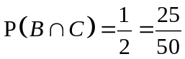.  Hence, some parts of (B ∩ C) must also intersect with A.  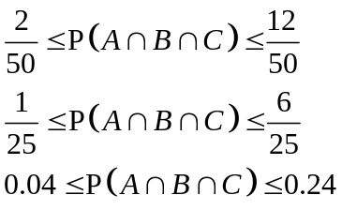

7i | Let μ be the mean distance Nelly can throw her shot-put.  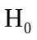: μ = 19.6  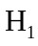: μ > 19.6
7ii | Level of significance: 5% (upper-tailed)  Under H₀, 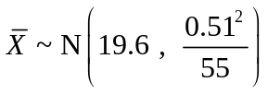 approximately by Central Limit Theorem  Test statistic: 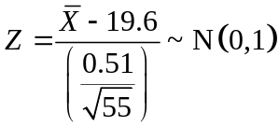 approximately  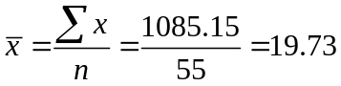  p-value = 0.0294 < 0.05, hence we reject H₀.  There is sufficient evidence at 5% level of significance level to claim that the new training method has improved Nelly’s performance.
7iii | It is not necessary, since n = 55 is large enough for us to use Central Limit Theorem to approximate 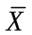to a normal distribution.
7iv | There is a 5% chance of concluding that the new training method has improved her performance when it actually has not.
8i | Let X be the number of camera lenses, out of 100, that are faulty.  X ~ B(100, 0.06)  P(X ≤ 7) = 0.7483494396 = 0.748 (3 sig. fig.)
8ii | At least 93 non-faulty lenses is equivalent to at most 7 faulty lenses.  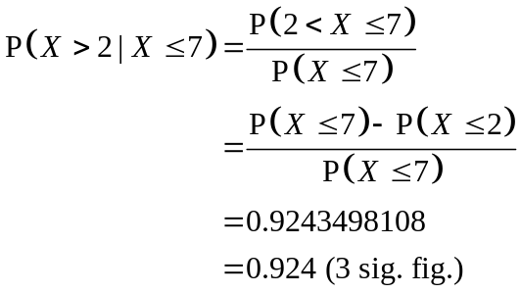
8iii | Less than 8 faulty lenses is equivalent to at most 7 faulty lenses.  Let Y be the number of boxes of 100 lenses, with at most 7 faulty lenses, out of 70.  Y ~ B(100, 0.7483494396)  Since n = 100 (large), np = 74.83494396 (>5) and nq = 25.16505604 (>5), we have  Y ~ N(74.83494396, 18.83225559) approximately.  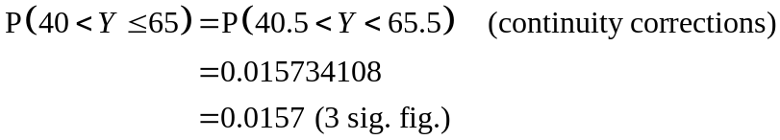
9ai | v
  u
9aii | v
  u
9bi | Using GC, r = −0.9912382757 = −0.991 (3 sig. fig.)  The r-value indicates a strong negative linear correlation between x and y. This means that as the time taken to complete the 2.4 km run increases, the distance attained in the standing broad jump tends to decrease linearly.
9bii | Since we are given a y value to find x, we use the line of x on y.  Line x on y: x = −9.685784852y + 32.59541712  When y = 2.28 m,  x = −9.685784852(2.28) + 32.59541712  = 10.51182766 = 10.5 mins (3 sig. fig.)
9biii | y on x: y = −0.08581x + 3.12473 --- (1)  x on y: x = −8.25664y + 29.16979 --- (2)  Solving (1) and (2) simultaneously, we get  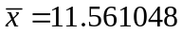  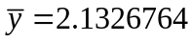  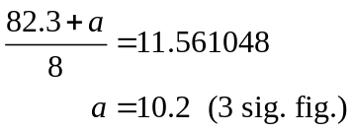  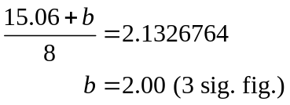
10i | Stratified sampling  - Split into mutually exclusive strata (e.g. Sec1,2,3,4, JC1,2)  - Randomly pick 5 students from each Sec level and 15 from each JC level  Quota sampling  - Split into mutually exclusive strata (e.g. Sec and JC)  - Decide on quota needed (e.g. 10 Sec, 40 JC)  - Interview first 10 Sec students and 40 JC students
10ii | - More representative of population, proportionate  - Convenience, speed, easy  [both in context]
10iii | a) 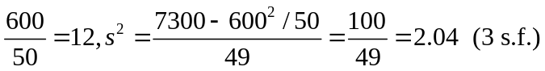  b) Sample mean is unbiased estimator for population mean so no change. Sample variance will differ, and is 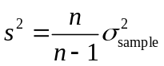 therefore 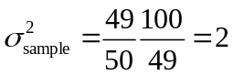
10iv | Since n = 50 (large), by Central Limit Theorem, 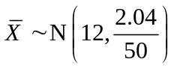 approximately.  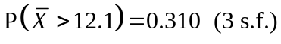
11i | Let X be the length of time a customer leaves a car in the car park of the shopping centre on a weekday.  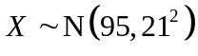  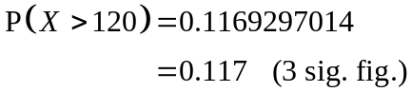
11ii | 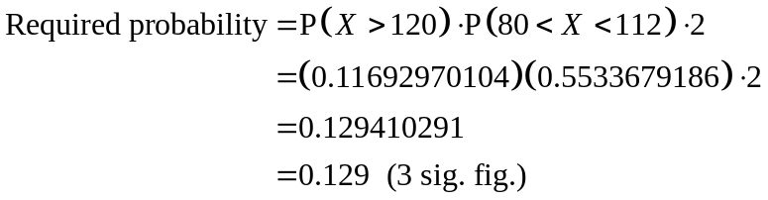
11iii | Let L be the amount of car park charges paid by Mr Ling in the two days he drove to the shopping centre.  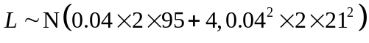  L ~ N(11.6, 1.4112)  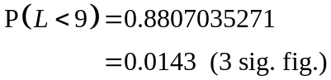
11iv | Let W be the no. of customers, out of 50, who leave their vehicles in the car park for more than 120 minutes.  W ~ B(50, 0.1169297014)  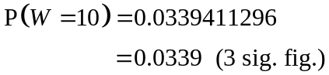
11v | Let Y be the length of time a customer leaves his vehicle in the car park of the shopping centre on a weekend.  Y ~ N(µ, σ²)  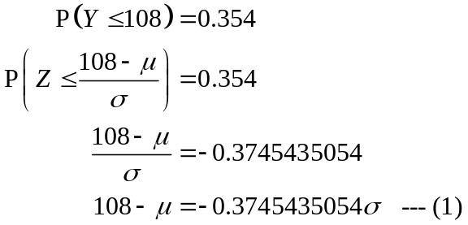  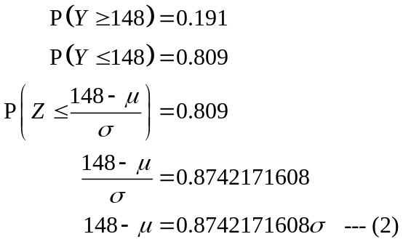  Solving (1) and (2) simultaneously, we get  